**Photo 1:** Tusabomu George Willy (front middle) – the District Planner Kibaale District, Uganda (Ph.D Scholar) makes a presentation about UWEP to Kibaale District Technical Planning Committee meeting on 27th March 2025 at the District Headquarters

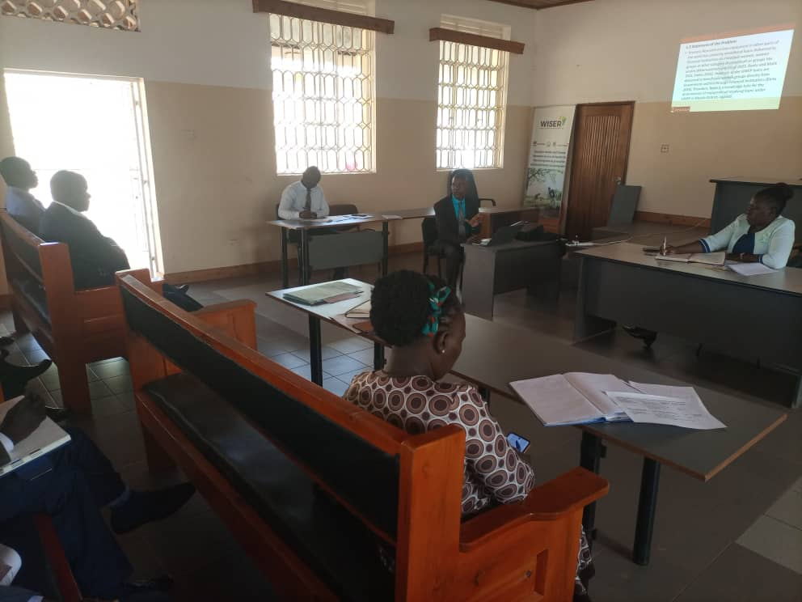

**Photo 2:** Tusabomu George Willy (middle) – the District Planner Kibaale District, Uganda (Ph.D Scholar) makes a presentation about UWEP to Kibaale District Technical Planning Committee meeting on 27th March 2025 at the District Headquarters. Madam Enid Kajumba (on the left) – the Deputy Chief Administrative Officer, Kibaale District chaired the meeting

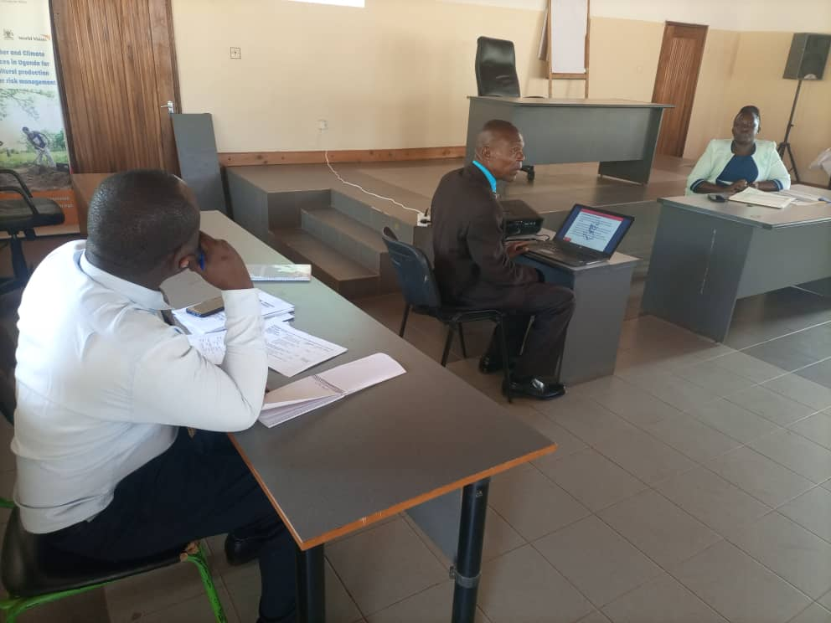

**Photo 3:** Tusabomu George Willy (front middle) – the District Planner Kibaale District, Uganda (Ph.D Scholar) makes a presentation about UWEP to Kibaale District Technical Planning Committee meeting on 27th March 2025 at the District Headquarters. The meeting was attended by Heads of Department, Selected Heads of Section and Lower Local Government representatives

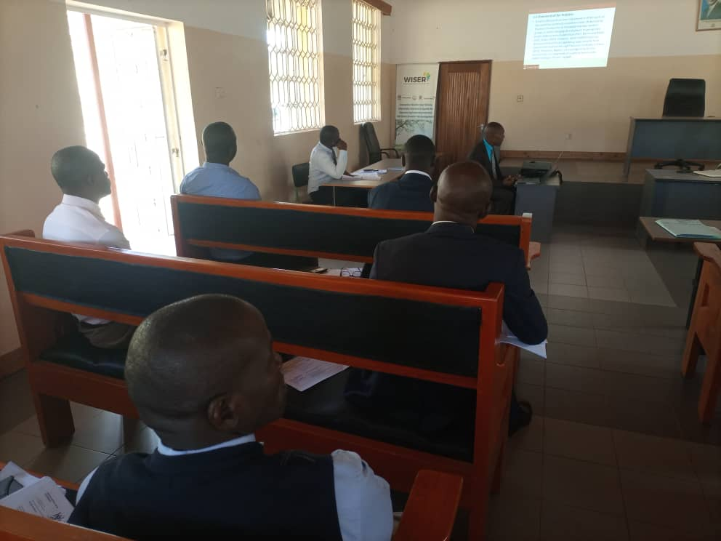

**Photo 4:** Kibaale District Heads of Department, Selected Heads of Section and Lower Local Government representatives attending the District Technical Planning Committee meeting on 27th March 2025 at the District Headquarters while Tusabomu George Willy – the District Planner Kibaale District (Ph.D Scholar) was making a presentation about UWEP

